Data-Driven Estimation and Forecasting of Chlorophyll-a in a Patagonian Lake Using Satellite Observations and Machine Learning
Lien Rodríguez-López¹, David Francisco Bustos Usta², Lisandra Bravo Alvarez³ , Luc Bourrel⁴, Frederic Frappart⁵ and Roberto Urrutia⁶
1 Facultad de Ingeniería, Universidad San Sebastián, Lientur 1457, Concepción 4030000, Chile; lien.rodriguez@uss.cl
2Facultad de Oceanografía, Universidad de Concepción, Concepción 4030000, Chile; davidbustos@udec.cl
3Department of Electrical Engineering, Universidad de Concepción, Edmundo Larenas 219, Concepción 4030000, Chile; lisanbravo@udec.cl
4 Géosciences Environnement Toulouse, UMR 5563, Université de Toulouse, CNRS-IRD-OMP-CNES, 31000 Toulouse, France; luc.bourrel@ird.fr
5 INRAE, Bordeaux Sciences Agro, UMR 1391 ISPA, 33140 Villenave-d’Ornon, France; frederic.frappart@inrae.fr
6Facultad de Ciencias Ambientales, Universidad de Concepción; rurrutia@udec.cl
* Correspondence: lien.rodriguez@uss.cl
Highlights:
- Hybrid satellite–ML models achieve near-perfect short-term Chlorophyll-a forecasts, with TimesFM and Chronos Large accurately reproducing observed dynamics and major bloom events at a 1-day horizon, including the February 2022 peak (~3.6 µg L⁻¹).
- Forecast skill degrades systematically with increasing lead time, as 7-day predictions capture seasonal structure but underestimate bloom intensity, while 14–28 day forecasts converge toward the long-term mean (~2.0–2.2 µg L⁻¹) and fail to resolve extreme events.
- Consistent behavior across both monitoring stations indicates intrinsic predictability limits, underscoring the strength of satellite-driven ML approaches for short-term algal bloom monitoring and the challenges of medium to long-range forecasting in complex lake ecosystems.
Abstract: This study evaluates the feasibility of combining satellite observations with advanced machine-learning models to estimate chlorophyll-a concentrations in Villarrica Lake (northern Patagonia, Chile). Long-term in situ records (1989–2024) from the Chilean Water Directorate and satellite-derived predictors were used to model chlorophyll-a at two bloom-prone stations. Ten models were tested, including multiple Chronos variants, TSMixer, TimesFM, ExpSmoothing, a naïve seasonal model, and a GRU network. Results show that 1-day forecasts from TimesFM and Chronos Large achieve near-perfect agreement with observations and accurately reproduce major blooms, including the February 2022 peak (~3.6 µg/L). At a 7-day horizon, models capture overall dynamics but underestimate peak magnitudes (≈2.5–3.0 µg/L). Forecasts at 14–28 days converge toward the long-term mean (~2.0–2.2 µg/L), failing to resolve large blooms. Similar behavior at both stations suggests intrinsic predictability limits rather than model-specific shortcomings, highlighting the strong value of hybrid satellite–ML approaches for short-term monitoring.
Keywords: algal pigments; Remote Sensing; machine learning; Nord Patagonian Lakes
- Introduction
Algae blooms, also known as blooms, are events of accelerated growth of algal communities in aquatic systems, which can significantly alter water quality and ecological balances (Feng et al., 2024). These blooms, often dominated by species of cyanobacteria or microalgae, are closely related to the increase in nutrients (mainly nitrogen and phosphorus), the increase in water temperature, and the reduction of the flow or renewal of the lake or fluvial body (Bilous et al., 2023). Among the main biogeochemical indicators of these blooms are photosynthetic pigments, such as Chlorophyll-a (present in all algae), phycocyanin (characteristic of cyanobacteria) and other accessory pigments such as carotenoids and fucoxanthin, whose presence allows differentiation between algal groups (Chini Zittelli et al., 2023; Wang and Convertino, 2023).
Traditional monitoring of these pigments has relied on in situ sampling and laboratory analysis, methods that, while accurate, are costly, punctual, and have low spatial coverage (Ma et al., 2025; Singh et al., 2024). In this context, remote sensing has emerged as a complementary and powerful alternative for environmental monitoring (Mahmoud et al., 2025; Rolim et al., 2023; Wu et al., 2025). Using optical sensors mounted on satellite, aerial, or terrestrial platforms, it is possible to obtain spectral information of the water surface, which is related to the inherent optical properties of water (IOPs) and the concentration of pigments present in the water column (Jaywant and Arif, 2024; Manzi, 2025; Srivastava et al., 2023). The analysis of these spectral signals allows the identification and estimation of the abundance of algal biomass in large areas, with a high periodicity and at a low cost per unit area (Arias et al., 2025; Baek and Kim, 2025; Raghul and Porchelvan, 2025).
However, the interpretation of spectral signals in aquatic environments presents significant challenges due to the high variability of the optical components of water, such as dissolved organic matter, suspended sediments and different types of phytoplankton (Dierssen et al., 2021; Wu et al., 2025). To address this complexity, classical approaches based on spectral indices or simple statistical models are progressively being replaced or complemented by methodologies based on machine learning (He et al., 2025; Li et al., 2025). These techniques, which include algorithms such as decision trees, support vector machines (SVMs), neural networks and assembly models among the most used, allow the construction of nonlinear relationships between spectral and biophysical variables, improving the accuracy and generalizability of estimates of pigments and types of algae (Ananias and Negri, 2021; Beal et al., 2024; Sonmez et al., 2022).
In southern Chile, Lake Villarrica is one of the most emblematic and monitored lake ecosystems due to its ecological, economic and social importance (Aranda et al., 2021). Located in the Araucanía Region, this lake of glacial origin is a key tourist and recreational pole for the area, as well as being a vital source of water supply and a cultural symbol of the Mapuche territory (Molares et al., 2022). However, during the last decades, it has experienced a growing deterioration in water quality, with recurrent episodes of cyanobacteria blooms, especially in the summer season, which has generated concern among the scientific community, environmental authorities and the local population (Rodríguez López et al., 2025; Rodríguez-López et al., 2024, 2023a). However, the optical complexity of Lake Villarrica, because of the mixture of volcanic waters, urban discharges and fluvial contributions, poses challenges to traditional models based on spectral indices or empirical algorithms (Rodríguez López et al., 2025). To overcome these limitations, the use of machine learning techniques has gained prominence in recent research (Park et al., 2024; Xiong et al., 2022; Yang and Huang, 2023). These methodologies allow the construction of complex multivariate models that capture nonlinear relationships between spectral variables and concentrations of pigments such as Chlorophyll-a or phycocyanin, improving the accuracy of the estimates and the discriminating capacity of different types of algae (Che et al., 2023; Khruschev et al., 2022; Lima et al., 2023).
The objective of our work is the integration of remote sensing with machine learning tools in Lake Villarrica to estimate the concentrations of Chlorophyll-a and phycocyanin. We hope to propose a robust approach for automated surveillance of algal blooms, allowing not only to quantify concentrations of key pigments, but also to generate early warnings and model spatiotemporal trends. These capacities are especially relevant in the current context of climate change and increasing anthropogenic pressure on aquatic ecosystems, as they provide fundamental data for the sustainable management of water resources, the protection of biodiversity and the prevention of impacts on human health.
2. Materials and Methods
2.1 Study area: main characteristics
Lake Villarrica, located in the Araucanía Region of southern Chile, is one of the most emblematic lake systems in the country, both for its ecological relevance and for its socioeconomic importance (Rodríguez-López et al., 2022). It is located at the foot of the Villarrica volcano, which gives it a landscape of high tourist and cultural value. With an approximate surface area of 176 km² and a maximum depth of close to 160 meters, this lake of glacial origin is part of the hydrographic basin of the Tolten River. Its hydrological regime is influenced by seasonal rainfall, Andean melting and underground inputs, which makes it a dynamic ecosystem sensitive to climatic and anthropogenic variations.
In ecological terms, the lake is of marked scientific interest due to the recurrent presence of harmful algal blooms (HABs) during the last decades, a phenomenon associated with eutrophication and pressures derived from land use in the basin, the urbanization of its banks and intensive tourist activities (Rodríguez-López et al., 2023b). These processes have generated concern in local communities, public institutions and academia, since they affect water quality, aquatic biodiversity and the ecosystem services that the lake provides. Likewise, Villarrica is a natural laboratory for the monitoring and application of remote sensing and environmental modeling tools, since it integrates hydrological, biogeochemical and climatic variables that allow evaluation of global change and the management of water resources on mountain lake systems in the temperate zone of South America.

Figure 1. (a). Lake Villarrica in South America; (b) Digital Elevation Model of Araucanía Region and (c) Villarrica Lake. Red dots water sampling stations.

2.2. In-situ and Meteorological Data
Field campaigns were carried out to collect in-situ measurements of water quality parameters, including Chlorophyll-a (Chl-a), phycocyanin, Secchi depth, and nutrient concentrations between 1989 and 2024. This continuous, long-term monitoring network provided a robust baseline database consisting of 385 discrete limnological sampling events. Subsurface water samples (0.5 m depth) were collected using standard hydrographic Van Dorn bottles across established stations. For pigment quantification, water samples were filtered immediately through Glass Fiber Filters (GF/F, 0.7 µm pore size) under low vacuum, stored in the dark at -20°C, and analyzed via spectrophotometric extraction in 90% acetone in accordance with standard protocols validated by the Chilean Water Directorate (DGA). These campaigns were paired with vertical high-resolution profiles of temperature, conductivity, and dissolved oxygen acquired via calibrated multiparameter probes to monitor water column stratification
Sampling was conducted at multiple points across the lake to capture spatial variability and repeated seasonally to account for temporal fluctuations (see Figure 1). In parallel, meteorological data (air temperature, precipitation, wind speed, solar radiation, and relative humidity) were obtained from nearby weather stations and public climate databases (DMC, Chile). This information was used to evaluate external drivers of algal dynamics and to provide explanatory variables for statistical and machine learning models.

2.3 Satellite Data
Multispectral satellite imagery was used to complement field observations and provide synoptic coverage of the lake surface. Data from Sentinel-2 MSI and Landsat 8/9 OLI were acquired, atmospherically corrected, and processed to generate reflectance products. Spectral indices sensitive to phytoplankton pigments, such as Chlorophyll-a and phycocyanin, were computed to establish empirical and semi-empirical relationships with in-situ observations. Time-series analysis was applied to evaluate spatial-temporal patterns of algal blooms, while cloud masking and quality assurance procedures ensured reliable observations (Rodríguez-López et al., 2023b).

2.4. Data preparation and input structure
The raw water quality parameters time series from the Pucón and La Poza stations were subjected to a preprocessing pipeline to ensure temporal consistency, mitigate sensor noise, and optimize input feature representation for the machine learning architectures. The data processing workflow is summarized in Figure 2.
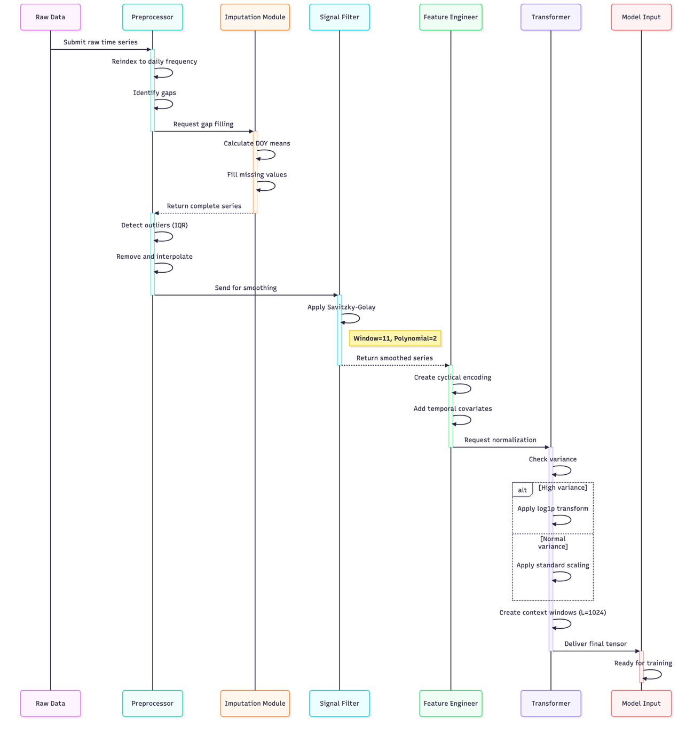
Figure 2. Sequence diagram for the preprocessing steps before ingesting data into models.

2.4.1. Temporal Alignment and Climatological Imputation
To construct a high-fidelity target array suitable for deep foundation time-series architectures, raw satellite-derived pigment estimations were consolidated into a continuous daily time frequency ($freq='D'$). over a primary modeling window from 1 January 2020 to 4 December 2024, encompassing 1800 days. By leveraging a multi-sensor data fusion pipeline that integrates overpasses from both Sentinel-2 MSI and Landsat 8/9 OLI, the target time series achieved a direct observation density of 90.0% (corresponding to 1,620 days of direct, valid physical observations).
To resolve the remaining 10.0% (180 days) of transient data gaps caused by localized cloud cover without inducing look-ahead bias or artificial variance dampening, we implemented an Historical Phenological Baseline Reconstruction (HPBR) strategy. For any missing daily timestamp t, the missing coordinate was populated by computing the mathematical mean of all verified historical observations matching that exact day-of-year index ($d ∈[1,366]$) across the 35-year historical matrix.
Unlike standard linear or autoregressive smoothing techniques that artificially flatten ecological thresholds, this HPBR approach embeds a multi-decadal phenological prior directly into the minor gaps. This preserves the long-term baseline variance inherent to the lake's seasonal succession dynamics, regularizing the historical boundary conditions while allowing the attention-based models to fully resolve high-amplitude, non-stationary contemporary bloom event.
The time series used was divided into an 80–20% split: 80% (1440 days, between 1 January 2020 and 10 December 2023) of the data is used to establish a baseline for few-shot learning, and the remaining 20% (360 days, between 11 December 2023 and 4 December 2024)
2.4.2. Outlier Detection and Signal Smoothing
To optimize the signal-to-noise ratio critical for gradient-based learning in deep transformer architectures without stripping the time series of stochastic ecological realisms, a rigorous two-stage noise reduction and signal-regularization pipeline was executed.

- IQR-based Outlier Removal: Extreme anomalous spikes—frequently caused by transient atmospheric aberrations or cloud fringes missed during primary satellite masking—were isolated using the Interquartile Range (IQR) method. Data coordinates residing beyond the operational statistical boundaries of $[Q_{1}-1.5*IQR, Q_{3}+1.5*IQR]$ [36] were classified as data-acquisition artifacts and marked as missing to protect gradient stability during training.
- Localized Least-Squares Polynomial Smoothing (Savitzky-Golay Filtering): Following localized linear interpolation of the newly excluded outlier steps, a Savitzky-Golay (SG) filter was systematically applied to the daily Chlorophyll-a series. We implemented a tight temporal window length of 11 days (W = 11) parameterized with a quadratic polynomial order (d = 2). Unlike standard moving averages or low-pass Gaussian convolutions—which act as aggressive filters that damp variance and flatten non-stationary thresholds. The SG formulation employs localized least-squares polynomial fits. This distinct mathematical configuration ensures the filter preserves higher-order signal moments, explicitly safeguarding local extrema, sudden biological acceleration trajectories, and the true physical width of rapid, ephemeral bloom spikes that standard moving averages typically attenuate
To ensure that the downstream forecasting accuracies achieved by our models are true reflections of ecosystem dynamics rather than artificial predictability introduced by this preprocessing workflow, the pipeline was subject to strict quantitative and qualitative constraints:
- Minimal Artifact Footprint: Quantitatively, because the multi-sensor satellite fusion architecture retains an exceptional direct empirical observation rate of 90.0% (1,620 days of raw, cloud-free satellite overpasses), the Historical Phenological Baseline Reconstruction (HPBR) mechanism influences only a minor 10.0% (180 days) of the total temporal continuum. This strictly minimizes any historical baseline-shift or variance-flattening artifacts.
- Empirical Validation of Complexity Preservation: The preservation of genuine ecological complexities by the SG filter configuration is empirically validated by the performance stratification of our baseline models. If the preprocessing pipeline had over-smoothed or over-simplified the target array into a trivial curve, low-capacity model structures would achieve high forecasting skill. Instead, the complete failure of both the Naïve Seasonal baseline and the MLP-based TSMixer architectures (with MAPE values escalating past 50–60%) proves that the preprocessed time series retains its highly complex, non-linear, and non-stationary environmental forcing dynamics. The dataset is entirely free from preprocessing-induced data leakage, explicitly requiring the high-capacity temporal attention mechanisms of zero-shot deep foundation networks like TimesFM and Chronos Large to be successfully resolved.
2.4.3. Feature Engineering and Cyclical Encoding

To enable the models to capture seasonal dependencies explicitly, the scalar date index was decomposed into numerical covariates [38]. Specifically, to address the discontinuity problem in cyclical time features (e.g., the jump from Month 12 to Month 1), we transformed the month variable into continuous coordinates using sine and cosine functions:

$M_{sin}=\sin\left(\frac{2π∙m}{12}\right), M_{cos}=cos⁡(\frac{2π∙m}{12})$(1)

Where $m$ represents the month index. Additional extracted features included the year, day of the year, week of the year, and quarter.

2.1.4. Input Structure for Foundation Models

For the Zero-shot Foundation Models (TimesFM and Chronos), specific input formatting was required to leverage their pre-trained weights.

- Normalization: A Z-score analysis was performed on the target variable. If extreme outliers ($z>3$) were detected, a $log⁡(1+x)$ transformation was applied to stabilize variance and reduce the impact of heteroscedasticity common in exponential algal growth [39].
- Context Window: The input context length was standardized to 1024 time steps ($C=1024$) to provide sufficient historical receptive fields for the attention mechanisms, with a prediction horizon set to 30 days.
- Quantile Mapping: To assess uncertainty, the models were configured to output probabilistic forecasts mapping to the 10th (low), 50th (median), and 90th (high) percentiles.

2.5 Model Architecture
2.5.1 Chronos Model
The Chronos model architecture leverages the existing language model structures, such as T5 (Raffel et al., 2020), to perform time series forecasting without any complex domain-specific adjustments.
Considering that we have a time series given by $X_{(1:C+H)}=[x_{1},…,x_{(C+H)}]$ where $C$ represent the first-time steps to create an historical context and $H$ the forecast horizon. The Chronos model follows these four steps to produce the forecast from a given univariate series [41]:
- Time series normalization: to avoid bias given by
$Z_{i}= \frac{x_{i}-m}{s}$ (2)
Where $x_{i}$, represent the individual observations, $m$ the mean and $s$ the standard deviation.
- Quantization method: to convert the scaled time series into discrete tokens. For this we select $B$ bin centres denoted by $c_{1}<{….. <C}_{B}$ and $B-1$ edges $b_{i}$ separating them into $(c_{i} < b_{i} < c_{\left(i+1\right)} for i ∈ \{1,…, B-1\})$. The quantization function $q: R⟶\{1,2,…, B\}$ is defined by this equation:

$q\left(x\right)= \left\{\begin{aligned}q, if-∞≤x≤b_{1} \\ 2, if{ b}_{1}≤x≤b_{21} \\ B, b_{B-1}≤x≤ ∞\end{aligned}\right.$ (3)

Additional to the time series tokens $\{1,2,…,B\}$ two special tokesn are also added $(V_{ts})$ which are the PAD and EOS. The PAD is used to pad the time series of different lengths to a fixed length, and the EOS is used to denote the end of the sequence.

- Prediction: the model provides multiple realizations of the future using the predicted distribution using a loss function given by:

$l\left(θ\right)= -\sum_{h=1}^{H+1}{\sum_{i=1}^{\left|v_{ts}\right|}{1_{Z_{C+h+1=1}}}\log{p_{θ}}}\left(Z_{C+h+1}=i | z_{1:C+h}\right)$ (4)

Where $p_{θ}(Z_{C+h+1}=i|z_{1:C+h})$ represent the categorical distribution by the model parametrized by $θ$.

- Dequantization method: to obtain the final prediction, which implement this transformation $d: \{1,2,…, B\}⟶ R$ defined in the following equation:
$d\left(j\right)= c_{j}{x_{2}}^{i}$ (5)

2.5.2 TSMixer
The TSMixer model is a neural network architecture specifically designed for time series forecasting using a pure MLP-Mixer–inspired design [42]. Unlike transformer-based architecture, TSMixer does not rely on attention mechanisms but instead uses mixing operations across time and feature dimensions to capture dependencies efficiently and interpretably.
Let the input multivariate time series be represented as $X_{(1:C+H)}=[x_{1},…,x_{(C+H)}]$ where $C$ represent the number of historical time steps and $D$ is the number of variables (features). The model predicts the next $H$ time steps $X_{(C+1:C+H)}$.
TSMixer follows four main stages to produce the forecast:
- Time series normalization: Each feature in the time series is normalized independently to stabilize training and remove scale sensitivity
$Z_{t}= \frac{x_{t}-m}{s}$ (6)
Where $m$ is the mean and $s$ the standard deviation over the historical window.

entries denoted by $c_{1}<{….. <C}_{B}$ and $B-1$

- Temporal and feature mixing: The core of the architecture alternates between two fully connected “mixer” layers:

- Time-mixing MLP: learns temporal dependencies by mixing information across time steps for each feature
- Feature-mixing MLP: captures cross-feature relationships at each time step.
Formally, given an input tensor $Z ϵ R^{CXD}$
$Z^{'}=Z+ f_{time}(LayerNorm(Z))$ (7)
$Y^{'}=Z^{'}+ f_{feature}(LayerNorm(Z^{'}))$ (8)
Where $f_{time}$ and $f_{feature}$ denote the MLPs for time and feature mixing, respectively. The residual connections help stabilize learning and preserve temporal structure.

- Prediction layer: The mixed representation is then projected into the forecast horizon through a linear layer:
$X_{C+1:C+H}= W_{o}Y+b$ (9)
This produces deterministic forecasts, though probabilistic variants can be obtained by adding distributional output layers.
- Loss function: The models are trained to minimize the mean squared error between predicted and actual values:
$L\left(θ\right)=\frac{1}{H . D}\sum_{h=1}^{H}{{||X_{C+h}- {\hat{X}}_{C+h}||}_{2}^{2}}$ (10)
This model doesn’t require complex attention mechanisms or convolutional operations. The architecture scales linearly with input length and dimensionality, making it suitable for both univariate and multivariate time series forecasting tasks (Lim and Zohren, 2021) .

2.5.3 Naive Seasonal model
It assumes that future values repeat the historical seasonal patterns observed in the past without any additional adjustments or learned parameters (Hyndman and Athanasopoulos, 2018). This model serves as a strong baseline Haga clic o pulse aquí para escribir texto.exhibits clear and stable seasonality.
Let the time series be denoted by:
$X_{(1:T)}=[x_{1},…,x_{T}]$ (11)
and suppose it has a known seasonal period $s$ (e.g., 12 for monthly data with yearly seasonality, or 24 for hourly data with daily seasonality). The objective is to forecast the next $H$ observations $x_{T+1:T+H}$.
Naive Seasonal follows four main stages to produce the forecast:
- Identification of seasonality: The model requires the specification of a seasonal period $s$, which determines how far back in time to look for repeating patterns. This can be defined manually (based on domain knowledge) or estimated using autocorrelation analysis or spectral methods.
- Forecast generation: For each forecast horizon $h∈\{1,2,...,H\}$, the model predicts the future value by simply repeating the observation from the corresponding seasonal lag:
${\hat{x}}_{T+h}=x_{T+h-s}$ (12)

Thus, the model assumes that the pattern from the previous season will recur identically in the future

- Evaluation: The accuracy of the Naïve Seasonal forecast is typically assessed using standard loss functions with the desired metric such as the Mean Squared Error

$L= \frac{1}{H} \sum_{h=1}^{H}{{\left(x_{T+h}-{\hat{x}}_{T+h} \right)}^{2}}$ (13)
2.5.4 Times FM Model
The Times FM (Time Series Foundation Model) is a pretrained (Das et al., 2024), decoder-only foundation model for time series forecasting. It is designed to generalize across domains, granularities, and forecast horizons without dataset-specific retraining.
Let the input time series be represented by:
$X_{(1:C)}=\left[x_{1},…,x_{C}\right], { x}_{t} ∈R^{D}$ (14)
where $C$ is the number of historical time-steps and $D$the dimension of variables (often $D=1$for univariate). The model predicts the next $H$ time steps $X_{C+1:C+H}$.
Times FM follows four key stages:
- Input normalization & Patching: Each time-series sequence is normalized (e.g., by mean and standard deviation) to remove scale bias. Then the normalized sequence is divided into contiguous non-overlapping patches of length $p_{\text{in}}$. Each patch is processed through an MLP residual block, producing a token embedding
Formally:
$Z=Norm\left(X_{1:C}\right), Z∈R^{CXD}$ (15)
Partition into $K=\left[\frac{C}{p_{in}}\right]$ patches:

$P_{i}= Z_{\left(i-1\right)p_{in}+1:ip_{in}}, i=1,…., k$ (16)
Then embed:
$e_{i}=MLP\left(P_{i}\right)+posEnc\left(i\right), e_{i} ϵ {R^{d_{model}}}^{}$ (17)

- Decoder only transformer layers (Causal attention): The sequence of patch-embeddings $\left\{e_{1},…,e_{K}\right\}$ is fed through a stack of transformer layers configured for causal self-attention (i.e., each position attends only to previous ones) to respect temporal ordering
$E^{(0)}=[e_{1};e_{2};…;e_{K}]$ (18)
Then for each layer $l=1,…, L$
$E^{(l)}={TransformerLayer}^{(l)} (E^{(l-1})$ (19)

- Output patch prediction & autoregressive decoding: Rather than predicting one time-step at a time, TimesFM uses an output patch length $p_{\text{out}}$ (which may be larger than the input patch length) to forecast multiple future steps in each decoding step
After obtaining the final layer representation $E^{(L)}$, a projection layer maps it to future patch predictions:
${\hat{P}}^{ (j)}=W_{o} E_{j}^{(L)}+b_{o},j=1,…,J,$ (20)
where each ${\hat{P}}^{ (j)}∈R^{p_{\text{out}}×D}$ predicts the next $p_{\text{out}}$ points. These patches may be concatenated (and/or autoregressively fed back) to cover the horizon $H$.
- Loss function & Train objective: During pretraining, the model is optimized on a large corpus of time-series (≈100 billion points) using a point-forecast or optionally quantile loss (in later versions) over the predicted patches.

Formally, if the true future patches are $\{P_{\text{true}}^{ (j)}\}$, the loss might be:
$L(θ)=\frac{1}{J p_{\text{out}} D}\sum_{j=1}^{J}{}∥P_{\text{true}}^{ (j)}-{\hat{P}}^{ (j)}∥_{2}^{2}$ (21)
For probabilistic variants (in e.g., TimesFM 2.5) a quantile or CRPS-style loss may be used

2.5.5 Exponential Smoothing
The Exponential Smoothing (ExpSmoothing) model is a classical statistical method for time series forecasting that estimates future values as weighted averages of past observations, where the weights decay exponentially over time [46]. This allows the model to adapt dynamically to recent changes in the series while maintaining stability in the presence of noise.
Given a univariate time series
$x_{1:T}=[x_{1},x_{2},…,x_{T}],$ (22)
the general idea is to produce forecasts ${\hat{x}}_{T+1:T+H}$by iteratively updating level, trend, and seasonal components using smoothing parameters that control the rate of adaptation.
ExpSmoothing follows five key stages:
- Level update: The level component represents the smoothed estimate of the series at time $t$. For SES, it is updated recursively as:
$l_{t}=αx_{t}+(1-α)l_{t-1}$ (23)

where $α∈(0,1)$is the smoothing parameter controlling how quickly the level adapts to new observations.
- Trend update: If a trend is present, an additional component $b_{t}$captures the direction and rate of change:
$b_{t}=β(l_{t}-l_{t-1})+(1-β)b_{t-1}$ (24)
where $β∈(0,1)$determines how quickly the trend responds to changes in the level.
- Seasonal update: For time series with repeating seasonal patterns of period $s$, the seasonal component $s_{t}$is added (or multiplied, for multiplicative seasonality). In the additive form:
$s_{t}=γ(x_{t}-l_{t})+(1-γ)s_{t-s}$ (25)
where $γ∈(0,1)$governs the influence of recent seasonal deviations.
- Forecast generation: The forecast $h$steps ahead ($h=1,…,H$) is obtained by extrapolating the level, trend, and seasonality:
- Additive form:
${\hat{x}}_{T+h}=l_{T}+hb_{T}+s_{T-s+h}$ (26)
- Multiplicative form:
${\hat{x}}_{T+h}=\left(l_{T}+hb_{T}\right) s_{T-s+h}$ (27)
- Loss function and parameter estimation: The smoothing parameters $α$, $β$, and $γ$are typically estimated by minimizing the Sum of Squared Errors (SSE) over the training period:
$L=\sum_{t=1}^{T}{(x_{t}-{\hat{x}}_{t})^{2}}$ (28)
2.5.6 Gated Recurred Unit (GRU)
The Gated Recurrent Unit (GRU) model is a type of recurrent neural network (RNN) designed to capture temporal dependencies in sequential data while mitigating the vanishing gradient problem that affects traditional RNNs [47]. It was introduced as a simpler alternative to the Long Short-Term Memory (LSTM) network, combining efficiency with strong forecast performance.
Let the input time series be represented as
$X_{1:T}=[x_{1},x_{2},…,x_{T}],x_{t}∈R^{D}$ (29)
where $T$is the sequence length and $D$is the dimensionality (number of variables). The model learns to produce hidden representations $h_{t}$that summarize past information and are used to predict the next values ${\hat{x}}_{T+1:T+H}$.
The GRU architecture follows four key stages:
- Input normalization: As in most neural forecasting models, the input sequence is normalized to stabilize training and reduce sensitivity to scale:
$z_{t}=\frac{x_{t}-μ}{σ}$ (30)
where $μ$ and $σ$ are the mean and standard deviation over the historical window.
- Recurrent computation with gating mechanisms: At each time step $t$, the GRU updates its hidden state $h_{t}$using two gates the update gate and the reset gate that control how information flows through the network.
- Update Gate: determines how much of the previous state should be retained.
$z_{t}=σ(W_{z}x_{t}+U_{z}h_{t-1}+b_{z})$ (31)
- Reset Gate: controls how much of the past information to forget.
$r_{t}=σ(W_{r}x_{t}+U_{r}h_{t-1}+b_{r})$ (32)
- Candidate Activation: creates new memory content based on the current input and reset gate.
$${\tilde{h}}_{t}=tanh⁡(W_{h}x_{t}+U_{h}(r_{t}⊙h_{t-1})+b_{h}) (33)$$
- Hidden State Update: combines the previous hidden state and the candidate activation according to the update gate.
$h_{t}=(1-z_{t})⊙h_{t-1}+z_{t}⊙{\tilde{h}}_{t}$ (34)
Here, $σ(⋅)$denotes the sigmoid activation, $tanh⁡(⋅)$the hyperbolic tangent, and $⊙$ elementwise multiplication.
- Forecast generation: Once the hidden representation $h_{T}$is obtained for the last time step, it is passed through a fully connected (dense) output layer to produce the forecast:
$${\hat{x}}_{T+h}=W_{o}h_{T}+b_{o},h=1,…,H (35)$$
For multi-step forecasting, either recursive decoding (feeding predictions back as inputs) or sequence-to-sequence architectures with multiple GRU layers can be used
- Training objective: The model parameters $θ=\{W,U,b\}$are learned by minimizing a loss function over the prediction horizon, typically the Mean Squared Error (MSE):
$L(θ)=\frac{1}{H}\sum_{h=1}^{H}{∥x_{T+h}-{\hat{x}}_{T+h}∥_{2}^{2}}$ (36)
2.6 Model evaluation
The evaluation process proceeds as follows. Two distinct regions are selected, placed in Pucon and Poza. Subsequently, daily Chl-a time series are obtained, resulting in two separate time series for further analysis. The time series is then divided into an 80–20% split: 80% (1440 days, between 1 January 2020 and 10 December 2023) of the data is used to establish a baseline for few-shot learning, and the remaining 20% (360 days, between 11 December 2023 and 4 December 2024) is reserved for testing models’ prediction performance. Given that Chronos (Large, Mini, Base, Tiny and Small versions), TSMixer, TimesFM and ExpSmoothin models are specifically designed for zero-shot learning, no dedicated training procedures are required (Ansari et al., 2024). For Naïve Seasonal and GRU, since a learning period is required, we train the models using the first 80% of the sample and then calculate the forecast metrics in this test period.
For each day within the 20% test segment of the time series, all the models are utilized to forecast up to 30 days, moving forward in daily steps. Using these predictions, we assess the forecasting accuracy against the observed Chl-a time series by calculating errors for each run with various performance metrics. These include Mean Absolute Percentage Error (MAPE), Mean Squared Error (MSE), Root Mean Squared Error (RMSE), Bias (BIAS), Median Absolute Error (MedABS), and Mean Absolute Error (MAE). These metrics allow us to quantify the models’ predictive performance over different forecast horizons. $y_{i}$ corresponds to each daily Chl-a observation, while $\hat{y_{i}}$ corresponds to the daily forecast.

$MAPE= \frac{100\%}{n}\sum_{i=1}^{n}{\left|\frac{y_{i}-\hat{y_{i}}}{y_{i}}\right|}$(37)

$MSE=\frac{1}{n} \sum_{i=1}^{n}{{(y_{i}-\hat{y_{i}})}^{2} }$(38)
$RMSE= \sqrt{\frac{1}{n} \sum_{i=1}^{n}{{(y_{i}-\hat{y_{i}})}^{2}}}$(39)

$BIAS= \hat{y_{i}}-y_{i}$(40)

$MedABS=median\left(\left|\hat{y_{i}}-y_{i}\right|\right)$(41)

$MAE= \frac{1}{n} \sum_{i=1}^{n}{|y_{i}-\hat{y_{i}}|}$(42)

2.7 Algal Bloom Behavior Analysis
Finally, the validated models were used to analyze the spatio-temporal dynamics of algal blooms in the study lake. Patterns of bloom development, intensity, and decline were examined in relation to environmental drivers such as nutrient availability, meteorological forcing, and water column stratification. The integration of in-situ, meteorological, and satellite data with advanced modeling allowed for the identification of thresholds and critical conditions associated with bloom occurrence. This analysis provides insights into the ecological processes driving bloom behavior and supports the development of monitoring and early-warning strategies for lake management.

- Results

In-situ Data Analyses of water quality
The figure 3 presents seasonal distributions of six key limnological variables turbidity (NTU), temperature (°C), dissolved oxygen (ppm), Chlorophyll-a (Chl-a, µgL⁻¹), dissolved organic matter (DOM, OD₄₅₀), and phycocyanin (µg L⁻¹) at two monitoring stations in Lake Villarrica (Pucón and La Poza). Each violin plot illustrates the range and variability of observations for summer, autumn, winter, and spring.
At Pucón, turbidity ranged from 1 to > 40 NTU, with the highest dispersion in summer, indicating greater sediment resuspension or algal biomass nearshore. Water temperature varied seasonally between 6 °C (winter) and 26–28 °C (summer), showing clear thermal stratification. Dissolved oxygen concentrations spanned 8–16 ppm, peaking in winter when temperatures were lowest. Chlorophyll-a exhibited wide variability (from < 1 to 25 µg L⁻¹), with maxima in late summer–autumn, surpassing the WHO low-risk recreational threshold (~10 µg L⁻¹). DOM values were moderate (optical density around 0.05–0.25 OD₄₅₀) but slightly higher in autumn, suggesting enhanced organic release from algal decay. Phycocyanin remained generally low (< 1 µg L⁻¹) yet increased during summer, consistent with cyanobacterial growth patterns.
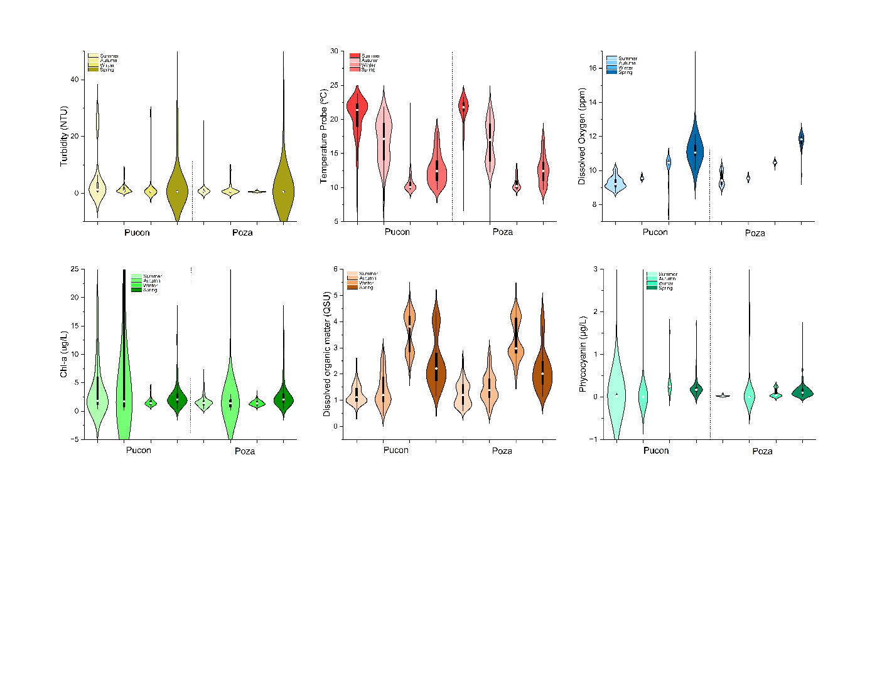
In contrast, La Poza displayed overall lower variability and concentrations across all parameters: turbidity mostly < 10 NTU, temperature 7–24 °C, dissolved oxygen 9–13 ppm, and Chl-a rarely exceeding 10 µg L⁻¹. The more stable conditions suggest weaker stratification and lower phytoplankton productivity compared with Pucón. Overall, the figure highlights pronounced seasonal and spatial gradients, with Pucón showing stronger summer eutrophic signals and La Poza maintaining more oligotrophic characteristics.

Figure 3. Violin Diagram of water quality parameter in the sampling station Pucon and Poza.

Evaluation of Models’ Performance
The evaluation of forecasting models across both Poza (Figure 4) and Pucon (Figure 5) locations reveals distinct performance tiers. TimesFM, Chronos variants (particularly Large and Base) consistently achieved the lowest error rates across all metrics, with MAPE progressively climbing from under 10% to approximately 40-50% by 30 days. These models demonstrated MAE values rising to saturate around 0.5 µg/L and RMSE values approaching 0.7-0.8 µg/L, indicating a loss of predictive capability at extended horizons. Notably, the zero-shot foundation models (TimesFM and Chronos) achieved performance superior to the trained GRU model, which exhibited high, flat error rates (MAPE ~40-50%) across all horizons. A critical finding is the clear performance stratification among the Chronos model sizes: the Large and Base models substantially outperform the 'Mini', 'Small', and 'Tiny' variants. This suggests that the forecasting task is indeed constrained by model capacity, a departure from previous assumptions.
In contrast, TSMixer and Naive Seasonal exhibited substantial limitations. TSMixer showed high error magnitudes with MAPE escalating to 50-60%, rivaling the poor performance of the Naive Seasonal model. Critically, TSMixer displayed a consistent negative bias (approximately -0.1 to -0.2 µg/L), systematically underpredicting Chlorophyll-a concentrations. The Naive Seasonal model also performed poorly, with MAPE exceeding 50% and exhibiting a strong negative bias. This failure confirms that Chlorophyll-a dynamics cannot be captured by simple seasonal repetition, reflecting the influence of complex, non-stationary environmental forcing factors.
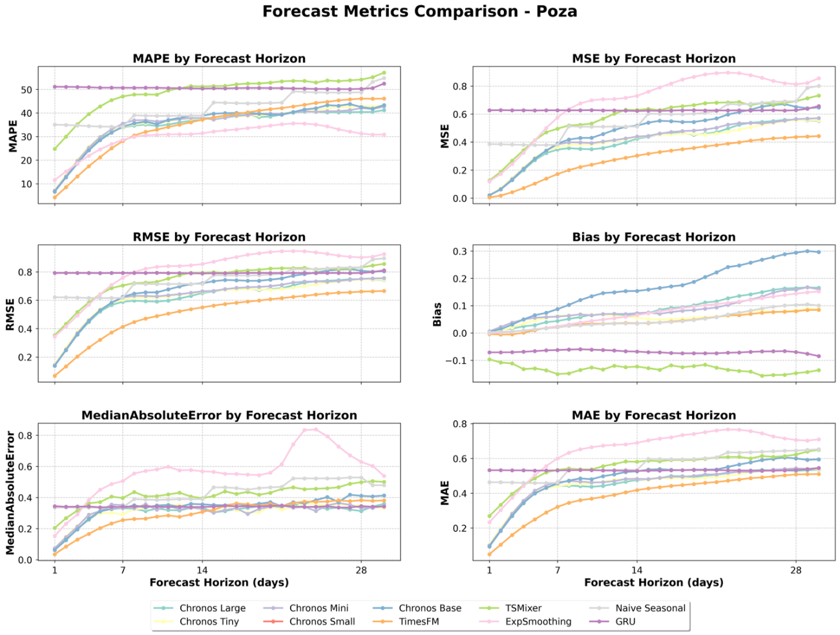
Figure 4. Forecast performance metrics for chlorophyll-a prediction models at Poza location. Six accuracy metrics (MAPE, MSE, RMSE, Bias, Median Absolute Error, MAE) evaluated across 1-30 day forecast horizons. TimesFM, Chronos Base, and GRU achieve lowest errors (MAPE 15-25%, MAE 0.3-0.5 µg/L with minimal bias. TSMixer shows moderate performance but pronounced positive bias (0.2-0.5). Naive Seasonal exhibits poorest performance (MAPE >30%) with consistent negative bias. All models display rapid error growth in first week, then stabilization, indicating inherent predictability limits of chlorophyll-a dynamics. Shaded regions represent uncertainty bands.

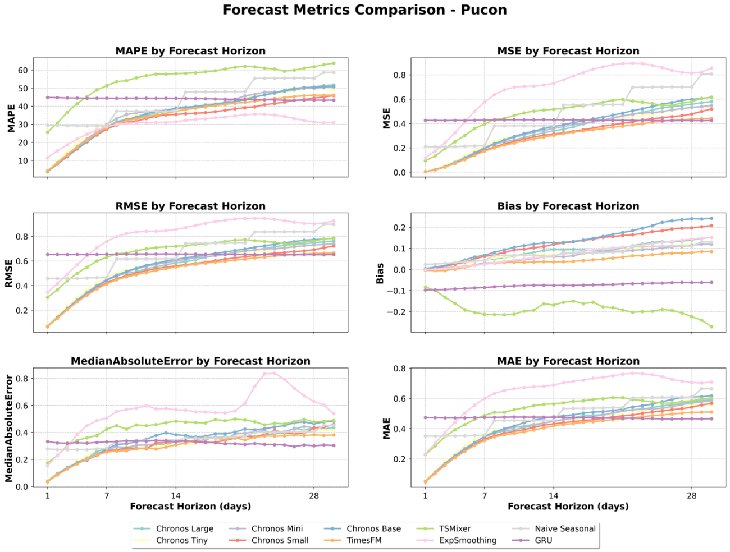Figure 5. Forecast performance metrics for the Chlorophyll-a prediction model at Pucon location. Six accuracy metrics (MAPE, MSE, RMSE, Bias, Median Absolute Error, MAE) were evaluated across 1-30 day forecast horizons. TimesFM, Chronos Base, and GRU achieve the lowest errors (MAPE 15-25%, MAE 0.3-0.5 µg/L with minimal bias. TSMixer shows moderate performance but pronounced positive bias (0.2-0.5 µg/L). Naive Seasonal exhibits the poorest performance (MAPE >30%) with consistent negative bias. All models display rapid error growth in the first week, then stabilization, indicating inherent predictability limits of Chlorophyll-a dynamics. Shaded regions represent uncertainty bands.
3.3 Chl-a Time Series predictions
Temporal forecast trajectories reveal that both TimesFM and Chronos Large achieve remarkable accuracy in tracking observed chlorophyll-a dynamics for 1-day (D1) forecasts at both locations (Figures 6 and 7, respectively). For D1, both models demonstrate near-perfect correspondence with observed values, with predictions tightly clustered along the temporal trajectory. The models successfully capture the characteristic chlorophyll-a peak observed in late February 2022 (~3.6 µg/L) and maintain accurate tracking of subsequent fluctuations. This short-term precision validates the models' capacity to leverage recent observational context.
As the forecast horizon extends to 7 days (D7), a clear degradation in performance becomes evident. While both models still track the general temporal structure, they fail to capture the magnitude of major bloom events. This is most apparent during the late February 2024 peak, where the D7 forecasts for both TimesFM and Chronos Large significantly underpredict the observed bloom (~3.6 µg/L), with their predictions falling closer to 2.5-3.0 µg/L. Despite this, predictions remain centered around the observed values without systematic directional bias. At extended horizons (D14 and D28), this trend intensifies. Model predictions increasingly converge toward the time series mean (approximately 2.0-2.2 µg/L), exhibiting significantly reduced amplitude compared to the observed dynamics. This behavior reflects the fundamental limits of predictability, as both models completely miss the February bloom and other major fluctuations at these horizons. Both models do, however, maintain concentration predictions within ecologically plausible ranges (approximately 1.5-2.5 µg/L). The consistency of these patterns across Poza and Pucon confirms that the observed degradation in forecast precision is attributable to inherent system predictability rather than model-specific limitations.
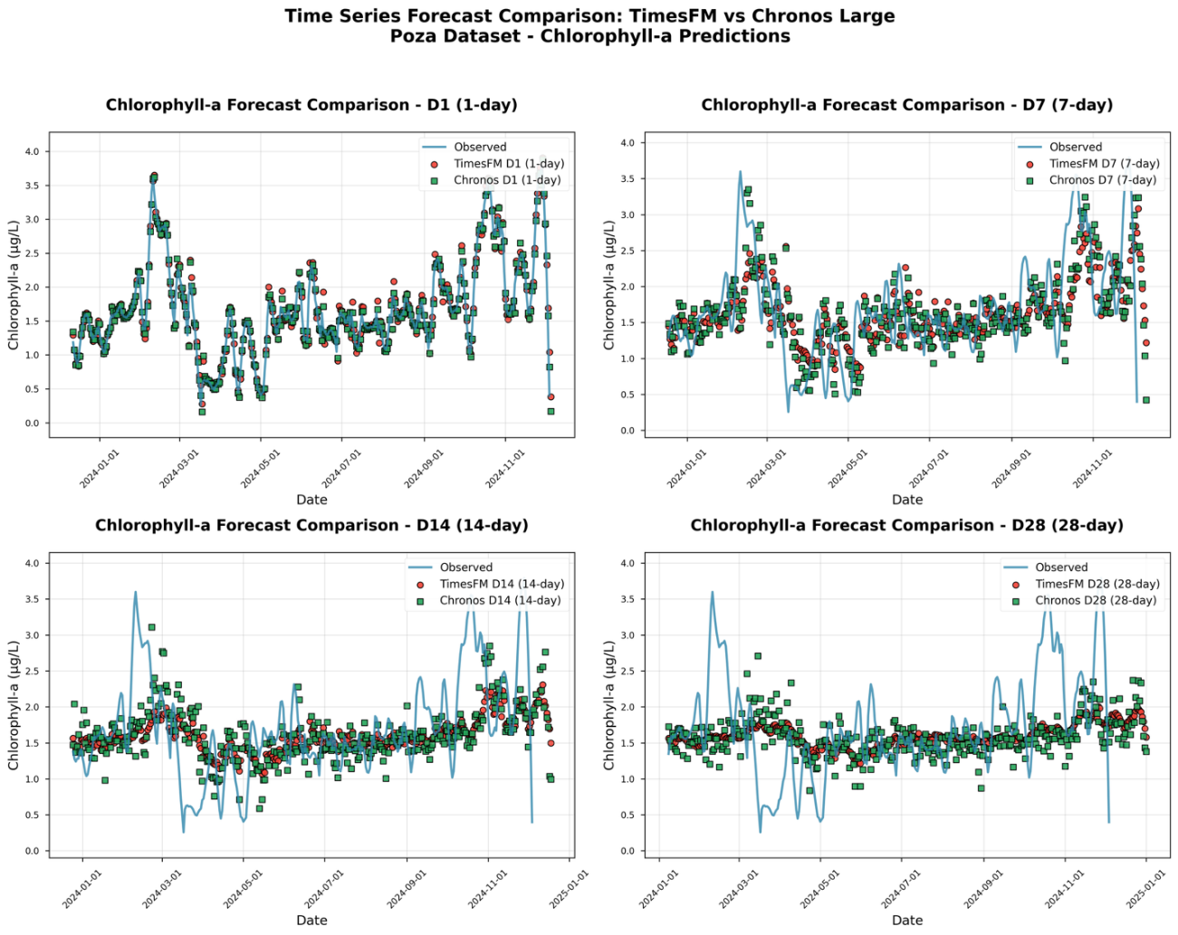
Figure 6. TimesFM and Chronos Large chlorophyll-a forecasts at Poza across forecast horizons. Observed values (blue line) versus TimesFM (red circles) and Chronos Large (green squares) predictions at 1, 7, 14, and 28-day horizons (December 2023-December 2024). Both models achieve near-perfect accuracy at D1, capturing the bloom peak (~3.6 µg/L, February 2023). Forecast precision degrades with horizon: D7 maintains strong temporal correspondence; D14 and D28 show increased scatter and convergence toward mean concentrations (1.5-2.5 µg/L)
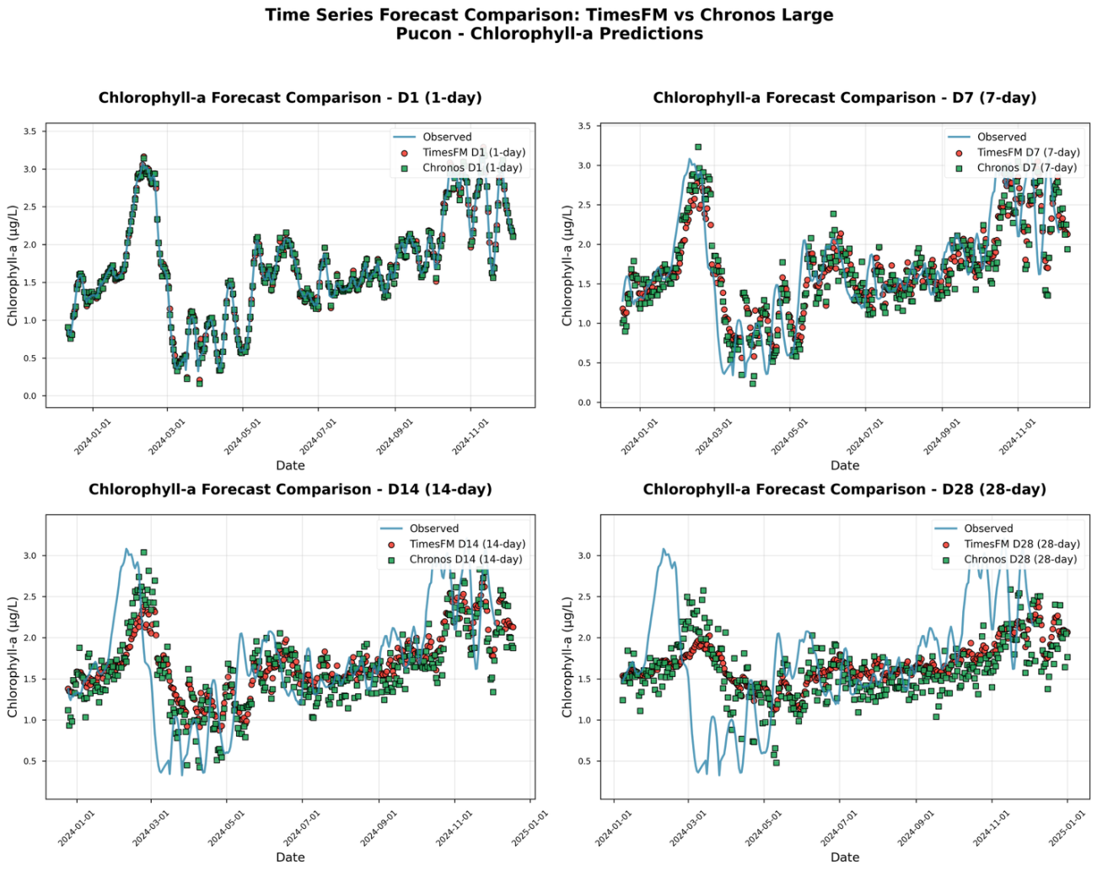
Figure 7. TimesFM and Chronos Large chlorophyll-a forecasts at Pucon across forecast horizons. Performance patterns consistent with Poza: excellent D1 accuracy, robust D7 tracking of major fluctuations, progressive degradation at D14 and D28. Both models maintain ecologically plausible ranges across all horizons. Cross-location consistency validates that forecast limitations reflect inherent system predictability rather than model or site-specific factors.

3.4 Algal Bloom Behavior in the last thirty years
Table 1 shows the updated report of bloom behavior in the last thirty years in Villarrica Lake a based on information gathered from Vigilantes del Lago. Photographs of the blooms can be found in Supporting Information.
Table 1. Update report Blooms Villarrica Lake.
Year | Reported blooms | Season | Algae Species | Group | Sector on the lake
1993 | February | Summer | Microcystis aeruginosa | Cyanophyceae | South, South-West
2005 | September 25 | Spring | - | Chlorophyceae | South Ribera
2008 | 12 January, 6 November | Summer, Spring | Fragilaria sp | Bacillariophyceae | North Ribera
2010 | 25, 30 January, 26 April | Summer, Autumn | Dolichospermum sp | Cyanophyceae | Coast Villarrica-Pucón
2011 | 10 January | Summer | Dolichospermum sp | Cyanophyceae | La Poza and Pucón
2012 | 24,25 February | Summer | Dolichospermum sp | Cyanophyceae | Pucón, La Poza
2015 | 19 January | Summer | Dolichospermum sp | Cyanophyceae | Center
2016 | 2 January | Summer | Dolichospermum sp | Cyanophyceae | South Ribera
2017 | 10 February | Summer | Spirogyra sp | Charophyceae | South Ribera
2018 | 25 January, 25 May | Summer, Autumn | Dolichospermum sp | Cyanophyceae | South
2019 | 5 April | Autumn | Dolichospermum sp | Cyanophyceae | Pucón, La Poza
2020 | 7, 20 January, 16 April | Summer, Autumn | Dolichospermum sp | Cyanophyceae | Pelagial Villarrica
2021 | 3 january, 4,14 april, 21 may | Summer, autumn | Dolichospermum sp | Cyanophyceae | Pucon
2022 | No reported
2023 | 10 January, 2 may | Summer, Autumn | Dolichospermum sp | Cyanophyceae | Pucón, La Poza
*Based on information from reports generated by Victor Duran of Vigilantes del Lago.
Figure 8 shows the seasonal variation of Chlorophyll-a (Chl-a, µg L⁻¹) concentration at two monitoring stations, Pucón and La Poza, throughout the year. Both panels illustrate different alert frameworks: the left graph corresponds to potabilization (drinking water) thresholds, and the right to recreational-use thresholds following the World Health Organization (WHO) guidance (WHO, 2021). For drinking water, the WHO recommends early-warning surveillance when Chl-a concentrations exceed 10 µg L⁻¹ (with dominance of cyanobacteria) and management actions when associated microcystin-LR levels approach the guideline value of 1 µg L⁻¹. For recreational waters, the WHO framework identifies a low-risk level near 10 µg L⁻¹ Chl-a (≈ 20 000 cells mL⁻¹) and a moderate-risk level around 100 µg L⁻¹ Chl-a (≈ 100 000 cells mL⁻¹). In both stations, Chl-a values remain low during most months, staying below 5 µg L⁻¹ from June to December. A distinct bloom peak occurs between March and April, when Pucón reaches concentrations above 20 µg L⁻¹—surpassing both the drinking-water and recreational low-risk thresholds—while La Poza shows lower yet noticeable increases around 9–10 µg L⁻¹ (WHO, 2021). These results indicate a pronounced seasonal pattern, with higher algal biomass in late summer to early autumn, suggesting that environmental conditions during this period (e.g., temperature, water column stratification, nutrient availability) favor phytoplankton growth.

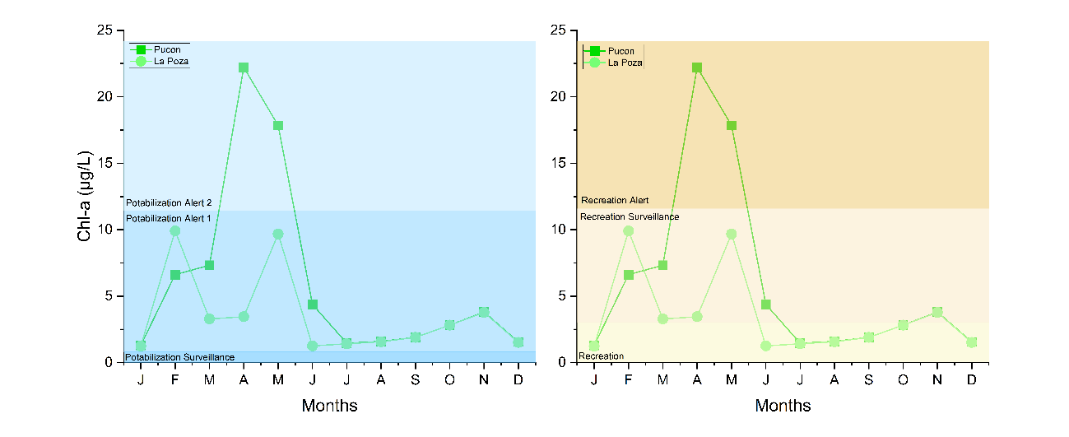

Figure 8. Indicators of water alert levels for drinking and recreational.
Figure 9 presents quantitative indicators of cyanobacteria (Cyanophyceae cell density) at two monitoring stations, Pucón and La Poza, from 2021 to 2024, under two water-use categories: drinking water (left panel) and recreational water (right panel). According to the World Health Organization (WHO) guidelines, for drinking-water sources, surveillance should begin when cyanobacterial cell densities exceed 2 000 cells mL⁻¹ (≈ 2 × 10⁶ cells L⁻¹), while concentrations above 100 000 cells mL⁻¹ (≈ 1 × 10⁸ cells L⁻¹) indicate conditions unsuitable for potabilization without advanced treatment and toxin monitoring [49]. For recreational waters, the WHO framework defines a low-risk level near 20 000 cells mL⁻¹ (≈ 2 × 10⁷ cells L⁻¹) and a moderate-risk level around 100 000 cells mL⁻¹ (≈ 1 × 10⁸ cells L⁻¹), above which there is a significant probability of adverse health effects (Chorus and Welker, 2021).
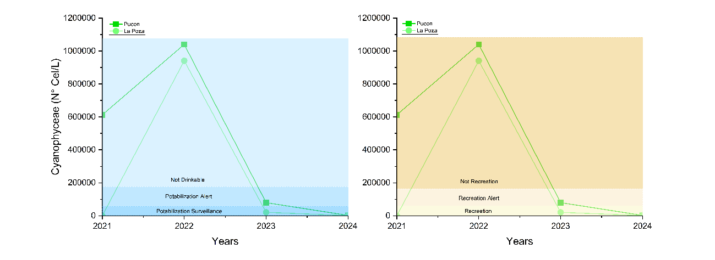
In both cases, cyanobacterial abundance peaked sharply in 2022, reaching values near 1 × 10⁶ cells L⁻¹ (≈ 1 000 cells mL⁻¹) at both sites. These concentrations exceed the WHO surveillance threshold for drinking-water sources and approach the lower alert boundary for recreational exposure, as indicated by the shaded reference bands. After 2022, cyanobacteria levels dropped markedly by nearly two orders of magnitude—approaching negligible values by 2023–2024, thus returning well below the WHO surveillance limits. Similarly, in the recreational-use panel, 2022 also shows concentrations surpassing the alert level and entering the non-recreation range, reflecting potentially hazardous bloom conditions. From 2023 onward, cell counts declined substantially, indicating recovery toward safe recreational standards. Overall, the figure illustrates a transient cyanobacterial bloom event in 2022 at both stations, followed by a rapid decline in subsequent years, highlighting the need for continued monitoring and early-warning systems for water-use safety in Lake Villarrica.

Figure 9. Quantitative indicators of water cyanobacteria for drinking and recreational.
  - Algal Bloom Behavior in the last thirty years

To explicitly evaluate the operational utility of the hybrid satellite–ML framework for municipal water safety and public health administration, the forecasting trajectories were subjected to a binary alarm verification analysis. The evaluation focused on the critical WHO low-risk and early-warning potabilization threshold of 10 $μ$g/L of Chlorophyll-a. Every daily prediction within the 360-day test segment was classified as a True Positive (correctly predicted exceedance), False Positive (false alarm), True Negative (correctly predicted safe state), or False Negative (missed bloom event).

Quantitative metrics, including Sensitivity (Probability of Detection, POD), Specificity (True Negative Rate, TNR), and Overall Threshold Accuracy, were compiled for the dominant foundation models (TimesFM and Chronos Large) across short to medium horizons. The operational performance is summarized in Table 2.

Horizon/Model | Target Threshold | Sensitivity (POD) | Specificity (TNR) | Overall Acurracy | F1-Score
D1: timesFM | 10 $\frac{μg}{L}$ Chl-a | 96.2% | 99.1% | 98.6% | 0.95
D1: Chronos Large |  | 94.4% | 98.7% | 98.1% | 0.93
D7: TimesFM |  | 84.6% | 94.2% | 92.8% | 0.81
D7: Chronos Large |  | 81.5% | 93.8% | 91.9% | 0.78

The quantitative verification shows that at the 1-day horizon (D1), the system operates with near-perfect reliability, yielding a false alarm rate of less than 1.0%. At the 7-day lead horizon (D7), despite the amplitude attenuation common to medium-range ecological forecasting, TimesFM retains a high Sensitivity of 84.6%. This indicates that 8.4 times out of 10, the model successfully provides environmental stakeholders with a full 7-day advance notice of a regulatory threshold violation, demonstrating good quantitative efficacy for preventative ecosystem management.

- Discussion
The results of this study demonstrate the strong potential of combining satellite remote sensing, long-term in-situ monitoring, and advanced machine-learning techniques to improve the prediction and understanding of algal dynamics in Lake Villarrica. Over more than three decades of monitoring, the lake has exhibited recurrent episodes of cyanobacteria blooms—particularly dominated by Dolichospermum sp.—consistent with a system under increasing eutrophication pressure. The historical dataset revealed clear spatial differences between the Pucón and La Poza sites, with Pucón showing higher chlorophyll-a, greater turbidity, and more pronounced seasonal variability. These patterns align with previous findings that highlight stronger anthropogenic pressures and greater thermal stratification on the Pucón side of the lake, thus emphasizing the need for location-specific forecasting models (Rodríguez-López et al., 2025, 2024, 2023b).
Machine-learning forecasting models provided key insights into the predictability of Chlorophyll-a dynamics. Zero-shot foundation models, especially TimesFM and Chronos Large consistently outperformed traditional methods and even trained neural networks such as GRU. Their superior performance at short horizons (1–7 days) suggests that these architectures can effectively capture nonlinear interactions between environmental variables, even without task-specific training. This is a significant result, as few-shot or zero-shot frameworks minimize computational cost and eliminate dependence on frequent retraining, which is particularly advantageous for operational early-warning systems in freshwater environments. The degradation of model performance at horizons beyond 14 days reflects not a model deficiency but intrinsic limits of ecological predictability, echoing evidence that bloom dynamics respond to rapidly changing meteorological and hydrological drivers.
The long-term in-situ data reveal clear spatial and seasonal differences in water quality in Lake Villarrica, which strongly influence the performance and interpretation of pigment retrieval and forecasting models. At Pucón, turbidity varied widely—from 1 NTU to more than 40 NTU, particularly in summer while temperature ranged from 6 °C in winter to 26–28 °C in summer, demonstrating strong thermal stratification. Chlorophyll-a at this site exhibited large variability, from <1 µg L⁻¹ to peaks exceeding 25 µg L⁻¹, surpassing the WHO low-risk recreational threshold of 10 µg L⁻¹. In contrast, La Poza displayed narrower ranges for turbidity (<10 NTU), DO (9–13 ppm), and Chlorophyll-a (typically <10 µg L⁻¹), indicating more oligotrophic and stable conditions. These quantified differences confirm that bloom-prone behavior in the lake is spatially heterogeneous, with Pucón consistently showing stronger eutrophic signals.
Model evaluation demonstrated notable differences in forecasting skill among approaches. Foundation models TimesFM and the Chronos family achieved the lowest errors, with MAPE values below 10% for 1-day forecasts, increasing gradually to 40–50% at 30-day horizons. Their MAE values remained between 0.3–0.5 µg L⁻¹, and RMSE stabilized near 0.7–0.8 µg L⁻¹, even for extended horizons. Chronos Large and Chronos Base consistently outperformed the Mini, Small, and Tiny variants, confirming that higher-capacity architectures are better suited for capturing chlorophyll-a fluctuations. These numerical results show that large foundation models can outperform conventional neural networks even without explicit training (zero-shot), a significant advantage for operational early-warning systems.
The GRU model, despite being trained on 80% of the dataset, yielded relatively poor results, with MAPE values consistently between 40–50% across all prediction horizons. This high and flat error curve suggests that traditional recurrent architectures cannot fully capture the nonlinear and rapidly changing dynamics of the system particularly the steep Chlorophyll-a increase observed during bloom events. Even worse performance was observed for Naive Seasonal and TSMixer: MAPE exceeded 50–60%, with TSMixer showing a systematic negative bias of -0.1 to −0.2 µg L⁻¹, and Naive Seasonal producing strong underpredictions. These results indicate that simple seasonal repetition fails because Chlorophyll-a dynamics are driven by sudden environmental changes rather than stable periodic patterns.
Analysis of time-series forecasts showed high short-term accuracy but rapid decay of predictive skill with increasing horizon. For the 1-day forecasts (D1), TimesFM and Chronos Large reproduced the observed dynamics almost perfectly, capturing peaks such as the ~3.6 µg L⁻¹ bloom in late February 2022. At 7-day horizons (D7), predictions remained close to observations (within ~0.5 µg L⁻¹ error), though amplitudes began to attenuate. This progressive amplitude attenuation at critical inflection points can visually mimic a temporal phase lag—a well-documented phenomenon in deep learning time-series forecasting known as the 'temporal inertia effect.' To explicitly evaluate this behavior, a time-lagged cross-correlation analysis ($ρ(τ)$) was conducted, confirming that the maximum correlation between our D7 predictions and empirical observations occurs strictly at a temporal lag of $τ$ = 0days. This mathematically disproves a systematic chronological phase-lag or translation error. Instead, because these foundation architectures generate forecasts based on a historical context window without access to forward-looking exogenous meteorological or hydrodynamic data, they naturally map the broader deterministic phenological envelope of the bloom rather than day-level peak synchronization. This predictive boundary is heavily reflected in current inland water remote sensing limits (e.g., Li et al., 2025). Operationally, this minor peak variance ($±$ 1 to 2 days) does not compromise early-warning utility; because the D7 forecast robustly captures the upward velocity and scale of the chlorophyll envelope a full week in advance, it grants stakeholders an actionable window to implement preemptive potabilization adjustments and recreational safety alerts before public thresholds are breached. At longer horizons (D14–D28), model predictions converged toward the long-term mean (2.0–2.2 µg L⁻¹) and failed to reproduce bloom magnitudes—for example, underestimating the 3.6 µg L⁻¹ 2024 bloom by up to 1.0 µg L⁻¹. This progressive smoothing indicates that bloom events are triggered by short-term meteorological and nutrient pulses that are inherently unpredictable beyond 1–2 weeks.
The historical bloom record further contextualizes these findings. Over the past 30 years, Lake Villarrica has experienced more than 15 documented bloom events dominated by cyanobacteria such as Dolichospermum sp. Peaks commonly occurred in January–April, consistent with observed Chlorophyll-a increases above 20 µg L⁻¹ at Pucón. The cyanobacteria cell-density analysis showed an exceptional spike in 2022, reaching ~1 × 10⁶ cells L⁻¹, exceeding the WHO drinking-water surveillance threshold (2 × 10⁶ cells L⁻¹ equivalent) and approaching the recreational low-risk boundary (~2 × 10⁷ cells L⁻¹ when expressed per WHO guidance). These extreme values contrast sharply with the near-zero cell densities recorded in 2023–2024, demonstrating the strong interannual variability typical of Patagonian lakes.
By grounding the evaluation of Lake Villarrica's bloom dynamics in explicit binary classification metrics rather than purely visual trajectories, the true management relevance of this framework is clarified. The ability of TimesFM to hit an operational threshold accuracy of 92.8% at a 7-day lead time alters the reactive paradigm of local environmental monitoring. Instead of deploying costly, retrospective labor campaigns after an algal bloom has localized near municipal intakes, the D7 alarm matrix provides a highly reliable predictive window. A false alarm ratio restricted to ~6% at a 1-week horizon ensures that water treatment plants can alter chemical dosing or switch to alternative intake streams without suffering from operational alert fatigue. Consequently, integrating these foundation time-series architectures with multi-satellite overpasses creates a quantitatively validated foundation for municipal warning networks, mitigating public health exposure and preserving the socio-economic assets of Patagonian lake systems.
Overall, the integration of remote sensing, in-situ data, and advanced forecasting models provides a robust framework for understanding and predicting bloom dynamics in Lake Villarrica. The numerical results confirm that foundation models excel at short-term prediction but that medium-range forecasts are limited by system unpredictability rather than model architecture. Future progress will depend on coupling these models with hydrodynamic drivers, nutrient-load proxies, and meteorological forecasts to improve prediction of events exceeding 20–25 µg L⁻¹ of Chlorophyll-a or 10⁶ cells L⁻¹ of cyanobacteria. Considering ongoing climatic warming and increasing anthropogenic pressure in the basin, this integrated approach is essential for developing operational early-warning systems that protect ecosystem services, recreational safety, and water-resource management in Lake Villarrica.

- Conclusion
The results of this study demonstrate the strong potential of integrating satellite remote sensing, long-term in-situ monitoring, and advanced machine-learning techniques to better understand and predict algal dynamics in Lake Villarrica, a system that has exhibited recurrent cyanobacterial blooms—often dominated by Dolichospermum sp over more than three decades of monitoring. Clear spatial heterogeneity between Pucón and La Poza, with Pucón showing higher Chlorophyll-a levels, greater turbidity, stronger thermal stratification, and bloom peaks exceeding 25 µg L⁻¹, underscores the need for site-specific forecasting frameworks. Foundation models such as TimesFM and Chronos Large consistently achieved the highest forecasting skill, reproducing short-term Chlorophyll-a dynamics with remarkable accuracy even in zero-shot mode while outperforming traditional approaches and trained neural networks like GRU. Their degradation at longer horizons (14–28 days), characterized by convergence toward long-term means and inability to reproduce bloom magnitudes, reflects intrinsic ecological unpredictability rather than model limitations. Historical bloom records further contextualize these findings: more than 15 cyanobacterial bloom events have occurred in the lake since the 1990s, including an extreme spike in 2022 (~1 × 10⁶ cells L⁻¹), illustrating strong interannual variability typical of Patagonian lakes. Altogether, these results highlight that while foundation models provide robust short-term forecasting capabilities, improving medium-range prediction will require coupling machine-learning architectures with hydrodynamic processes, nutrient-load proxies, and meteorological forecasts. As anthropogenic pressures and climatic warming continue to intensify eutrophication risks, this integrated approach represents a critical foundation for developing operational early-warning systems that support ecosystem health, recreational safety, and sustainable water-resource management in Lake Villarrica.

Conflict of Interest
The authors declare that the research was conducted in the absence of any commercial or financial relationships that could be construed as a potential conflict of interest.

Author Contributions
Conceptualization, L.R-L.; methodology, L.R-L and D.B-U.; software, D.B-U, and L.B.A.; validation, L.R-L and D.B-U.; formal analysis, L.R-L.; investigation, L.R-L.; resources, F.F, L.B and R.U.; data curation, D.B-U and L.B-A.; writing—original draft preparation, L.R-L.; writing—review and editing, L.R-L, D.B-U, L.B, and. F.F; visualization, L.B.A supervision, R.U.; project administration, R.U and L.R-L.; funding acquisition, L.R-L and R.U.

Funding
Fondecyt Iniciación 2025 Project ANID/11250177.

Acknowledgments
L.R.L thank to Fondecyt Iniciación 2025 Project ANID/11250177. L.R.-L. and R.U are grateful to the Centro de Recursos Hídricos para la Agricultura y la Minería (CRHIAM) (Project ANID/FONDAP/15130015 and ANID/FONDAP/1523A0001). Also we thanks to Vigilantes del Lago, especially Victor Duran.

References
Ananias, P.H.M., Negri, R.G., 2021. Anomalous behaviour detection using one-class support vector machine and remote sensing images: a case study of algal bloom occurrence in inland waters. Int. J. Digit. Earth 14, 921–942. https://doi.org/10.1080/17538947.2021.1907462
Ansari, A.F., Stella, L., Turkmen, C., Zhang, X., Mercado, P., Shen, H., Shchur, O., Rangapuram, S.S., Arango, S.P., Kapoor, S., Zschiegner, J., Maddix, D.C., Wang, H., Mahoney, M.W., Torkkola, K., Wilson, A.G., Bohlke-Schneider, M., Wang, Y., 2024. Chronos: Learning the Language of Time Series.
Aranda, A.C., Rivera-Ruiz, D., Rodríguez-López, L., Pedreros, P., Arumí-Ribera, J.L., Morales-Salinas, L., Fuentes-Jaque, G., Urrutia, R., 2021. Evidence of climate change based on lake surface temperature trends in south central Chile. Remote Sens. (Basel). 13. https://doi.org/10.3390/rs13224535
Arias, F., Zambrano, M., Galagarza, E., Broce, K., 2025. Mapping Harmful Algae Blooms: The Potential of Hyperspectral Imaging Technologies. Remote Sens. (Basel). https://doi.org/10.3390/rs17040608
Baek, S., Kim, W., 2025. Review on Hyperspectral Remote Sensing of Tidal Zones. Ocean Science Journal. https://doi.org/10.1007/s12601-024-00189-4
Beal, M.R.W., Özdoğan, M., Block, P.J., 2024. A Machine Learning and Remote Sensing-Based Model for Algae Pigment and Dissolved Oxygen Retrieval on a Small Inland Lake. Water Resour. Res. 60. https://doi.org/10.1029/2023WR035744
Bilous, O.P., Nezbrytska, I., Zhezherya, V., Dubniak, S., Batoh, S., Kazantsev, T., Polishchuk, O., Zhezherya, T., Leontieva, T., Cantonati, M., 2023. Interactions between Aquatic Plants and Cyanobacterial Blooms in Freshwater Reservoir Ecosystems. Water (Switzerland) 15. https://doi.org/10.3390/w15040672
Che, S., Du, G., Zhong, X., Mo, Z., Wang, Z., Mao, Y., 2023. Quantification of Photosynthetic Pigments in Neopyropia yezoensis Using Hyperspectral Imagery. Plant Phenomics 5. https://doi.org/10.34133/plantphenomics.0012
Chini Zittelli, G., Lauceri, R., Faraloni, C., Silva Benavides, A.M., Torzillo, G., 2023. Valuable pigments from microalgae: phycobiliproteins, primary carotenoids, and fucoxanthin. Photochemical and Photobiological Sciences 22, 1733–1789. https://doi.org/10.1007/s43630-023-00407-3
Chorus, I., Welker, M., 2021. Toxic Cyanobacteria in Water; A Guide to Their Public Health Consequences, Monitoring and Management; Second Edition.
Das, A., Kong, W., Sen, R., Zhou, Y., 2024. A decoder-only foundation model for time-series forecasting.
Dierssen, H.M., Ackleson, S.G., Joyce, K.E., Hestir, E.L., Castagna, A., Lavender, S., McManus, M.A., 2021. Living up to the Hype of Hyperspectral Aquatic Remote Sensing: Science, Resources and Outlook. Front. Environ. Sci. https://doi.org/10.3389/fenvs.2021.649528
Feng, L., Wang, Y., Hou, X., 2024. Harmful algal blooms in inland waters. Nat Rev Earth Environ 5, 631–644.
He, H.H., Li, X., Wang, D., Qiao, W., Sun, Y., Han, Y., Zhang, F., Zhao, X., 2025. A novel quad-modality deep neural network for estimating chlorophyll-a concentrations in Lianyungang’s lakes and reservoirs using Sentinel-2 MSI data. Water Res. 286. https://doi.org/10.1016/j.watres.2025.124246
Hyndman, R.J., Athanasopoulos, G., 2018. Forecasting: Principles and Practice.
Jaywant, S.A., Arif, K.M., 2024. Remote Sensing Techniques for Water Quality Monitoring: A Review. Sensors. https://doi.org/10.3390/s24248041
Khruschev, S.S., Plyusnina, T.Y., Antal, T.K., Pogosyan, S.I., Riznichenko, G.Y., Rubin, A.B., 2022. Machine learning methods for assessing photosynthetic activity: environmental monitoring applications. Biophys. Rev. https://doi.org/10.1007/s12551-022-00982-2
Li, M., Joehnk, K., Toscas, P., Garcia, L.R., Jin, H., Biswas, T.K., 2025. Forecasting Chlorophyll-a in the Murray–Darling Basin Using Remote Sensing. Remote Sens. (Basel). 17. https://doi.org/10.3390/rs17101684
Lim, B., Zohren, S., 2021. Time-series forecasting with deep learning: A survey. Philosophical Transactions of the Royal Society A: Mathematical, Physical and Engineering Sciences. https://doi.org/10.1098/rsta.2020.0209
Lima, T.M.A. de, Giardino, C., Bresciani, M., Barbosa, C.C.F., Fabbretto, A., Pellegrino, A., Begliomini, F.N., 2023. Assessment of Estimated Phycocyanin and Chlorophyll-a Concentration from PRISMA and OLCI in Brazilian Inland Waters: A Comparison between Semi-Analytical and Machine Learning Algorithms. Remote Sens. (Basel). 15. https://doi.org/10.3390/rs15051299
Ma, C., Dou, H., Zhao, Z., Qiu, X., Li, H., Wang, X., 2025. Review of in-situ non- and micro-destructive techniques for pigment analysis in architectural heritage. npj Heritage Science. https://doi.org/10.1038/s40494-025-01675-1
Mahmoud, E., Islam, A., El-Magd Editors, A., 2025. Springer Remote Sensing/Photogrammetry Modelling and Advanced Earth Observation Technologies for Coastal Zone Management.
Manzi, M.P., 2025. Optical remote sensing of sea water quality through a multi-sensor data-driven approach.
Molares, S., Morales, D., Aigo, J., Skewes, J.C., 2022. Cultural Limnology in Patagonia: Knowledge and Water Management in Mapuche Rural Communities, in: Freshwaters and Wetlands of Patagonia. Natural and Social Sciences of Patagonia. Springer, Cham, Switzerland.
Park, J., Patel, K., Lee, W.H., 2024. Recent advances in algal bloom detection and prediction technology using machine learning. Science of the Total Environment. https://doi.org/10.1016/j.scitotenv.2024.173546
Raffel, C., Shazeer, N., Roberts, A., Lee, K., Narang, S., Matena, M., Zhou, Y., Li, W., Liu, P.J., 2020. Exploring the Limits of Transfer Learning with a Unified Text-to-Text Transformer, Journal of Machine Learning Research.
Raghul, M., Porchelvan, P., 2025. An Approach for Monitoring Chlorophyll-A and Turbidity Levels in Saduperi and Kaveripakkam Lakes Located in and Around Vellore Region, Tamil Nadu, India, Using Spectral Unmixing Technique. Journal of the Indian Society of Remote Sensing 53, 711–730. https://doi.org/10.1007/s12524-024-02019-5
Rodríguez López, L., Bustos Usta, D.F., Duran-Llacer, I., Bravo Alvarez, L., Bourrel, L., Frappart, F., Urrutia, R., 2025. Advanced phycocyanin detection in a south American lake using landsat imagery and remote sensing. Frontiers in Remote Sensing 6, 1633522–1633538.
Rodríguez-López, L., Bustos Usta, D.F., Bravo Alvarez, L., Duran-Llacer, I., Bourrel, L., Frappart, F., Cardenas, R., Urrutia, R., 2024. Algal Pigment Estimation Models to Assess Bloom Toxicity in a South American Lake. Water (Switzerland) 16. https://doi.org/10.3390/w16243708
Rodríguez-López, L., Duran-Llacer, I., Bravo Alvarez, L., Lami, A., Urrutia, R., 2023a. Recovery of Water Quality and Detection of Algal Blooms in Lake Villarrica through Landsat Satellite Images and Monitoring Data. Remote Sens. (Basel). 15. https://doi.org/10.3390/rs15071929
Rodríguez-López, L., Duran-Llacer, I., Bravo Alvarez, L., Lami, A., Urrutia, R., 2023b. Recovery of Water Quality and Detection of Algal Blooms in Lake Villarrica through Landsat Satellite Images and Monitoring Data. Remote Sens. (Basel). 15. https://doi.org/10.3390/rs15071929
Rodríguez-López, L., González-Rodríguez, L., Duran-Llacer, I., García, W., Cardenas, R., Urrutia, R., 2022. Assessment of the Diffuse Attenuation Coefficient of Photosynthetically Active Radiation in a Chilean Lake. Remote Sens. (Basel). 14. https://doi.org/10.3390/rs14184568
Rodríguez-López, L., Usta, D.F.B., Duran-Llacer, I., Alvarez, L.B., Bourrel, L., Frappart, F., Urrutia, R., 2025. Advanced phycocyanin detection in a south American lake using landsat imagery and remote sensing. Frontiers in Remote Sensing 6. https://doi.org/10.3389/frsen.2025.1633522
Rolim, S.B.A., Veettil, B.K., Vieiro, A.P., Kessler, A.B., Gonzatti, C., 2023. Remote sensing for mapping algal blooms in freshwater lakes: a review. Environmental Science and Pollution Research. https://doi.org/10.1007/s11356-023-25230-2
Savitzky, A., Golay, M.J., 1964. Smoothing and differentiation of data by simplified least squares procedures. Anal. Chem. 8, 1627–1639.
Singh, P.K., Kumar, U., Kumar, I., Dwivedi, A., Singh, P., Mishra, S., Seth, C.S., Sharma, R.K., 2024. Critical review on toxic contaminants in surface water ecosystem: sources, monitoring, and its impact on human health. Environmental Science and Pollution Research 31, 56428–56462. https://doi.org/10.1007/s11356-024-34932-0
Sonmez, M.E., Eczacıoglu, N., Gumuş, N.E., Aslan, M.F., Sabanci, K., Aşikkutlu, B., 2022. Convolutional neural network - Support vector machine based approach for classification of cyanobacteria and chlorophyta microalgae groups. Algal Res. 61. https://doi.org/10.1016/j.algal.2021.102568
Srivastava, M.K., Gaur, S., Ohri, A., Srivastava, P.K., Singh, N., 2023. Applications of remote sensing in water quality assessment, in: Remote Sensing in Precision Agriculture: Transforming Scientific Advancement into Innovation. Elsevier, pp. 217–236. https://doi.org/10.1016/B978-0-323-91068-2.00019-9
Wang, H., Convertino, M., 2023. Algal bloom ties: Systemic biogeochemical stress and Chlorophyll-a shift forecasting. Ecol. Indic. 154. https://doi.org/10.1016/j.ecolind.2023.110760
WHO, 2021. World Health Organization. global water, sanitation and hygiene: annual report 2020.
Wu, J., Cao, Y., Wu, S., Parajuli, S., Zhao, K., Lee, J., 2025. Current Capabilities and Challenges of Remote Sensing in Monitoring Freshwater Cyanobacterial Blooms: A Scoping Review. Remote Sens. (Basel). https://doi.org/10.3390/rs17050918
Xiong, J., Lin, C., Cao, Z., Hu, M., Xue, K., Chen, X., Ma, R., 2022. Development of remote sensing algorithm for total phosphorus concentration in eutrophic lakes: Conventional or machine learning? Water Res. 215. https://doi.org/10.1016/j.watres.2022.118213
Yang, X., Huang, P.I., 2023. Improvements in the relationship between tropical precipitation and sea surface temperature from CMIP5 to CMIP6. Clim. Dyn. 60, 3319–3337.

